4th International Scientific Conference on Professional Studies (ISCPS 2026)
29 May, 2026 Faculty of Professional Studies, University Aleksandër Moisiu Durrës

Title of Your Paper for the 4th International Scientific Conference on Professional Studies (ISCPS 2026)
First Author (full name- and surname)
e-mail Institution/Organization/
City, Country

Co-author/s
e-mail Institution/Organization/
City, Country

……..

ABSTRACT
This document provides a template for writing papers for the 4th International Scientific Conference on Professional Studies (ISCPS 2026). The full paper is to be submitted in MS-Word format and written according to the instructions mentioned below.
The abstract should appear on the top of the first page, after the title of the paper under the heading given as ‘Abstract’. Under the title of the paper, details of the author(s) including email, name and institution name & place are to be given. The abstract of the full paper should be an explicit summary that relates the main research topic, the methodology, results, discussions and conclusions. Abstract and full paper should be single-spaced in 12-point type, and Times New Roman font. Abstract should be one paragraph and up to 250 words.
Keywords: Up to five keywords, 12-point type.

Full papers: 6-10 pages
You should format your paper exactly like this document. The template file contains the required formatted styles for your paper. All relevant illustrations, tables, and equations can be correctly inserted following the examples in this template.

INTRODUCTION
It is expected that authors will submit a carefully written and proofread material. Spelling and grammatical errors, as well as language usage problems, are expected to be avoided in the final submission. It is suggested that the paper length should be between 6 and 10 pages with a single-spaced 12-point type and Times New Roman font. Papers should be written in English, clearly describe the background of the subject, the authors work, including the methods used, and concluding discussion on the importance of the work.

PAPER FORMAT
The uniform outlook will help the reader to follow the proceedings. The paper must be in A4 format with 20 mm (0.8 inch) margins left, right, top and bottom. Header and footer shall be positioned 16 mm (0.65 inch) from the edge.
All text paragraphs should be single spaced, with the first line intended by 10 mm (0.4 inch). Double spacing should only be used before and after headings and subheadings as shown in this example. Position and style of headings and subheadings should follow this example. No spaces should be placed between paragraphs.

Header, Footer, Page Numbering
The template is in A4 format with 20 mm (0.8 inch) margins left, right, top and bottom. Header and footer shall be positioned 16 mm (0.65 inch) from the edge.

Fonts
The body of your paper should use 12-point Times New Roman font. The available styles available are bold, italic and underlined. It is recommended that text in figures not to be smaller than 9-point font size.

Tables and Figures
Figure captions and table headings should be sufficient to explain the figure or table without the need to refer to the text. Figures and tables that are not cited in the text should not be presented.
The following is an example for the Tables.
Table 1 Title of Example Table

AAA | Type X |  |  |  | Type Y
AAA | Item1 | Item2 | Item3 | Item4 | Item1 | Item2 | Item3 | Item4
BBB | 18 | 44 | 41 | 13 | 17 | 43 | 40. | 10
CCC | 24 | 60. | 61 | 28 | 26 | 63 | 65 | 19
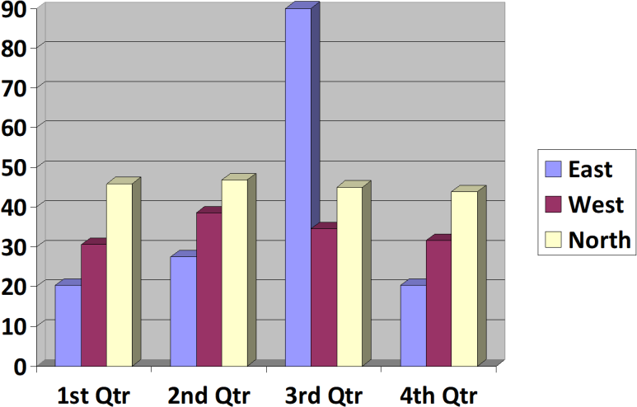
Tables and figures should be placed close to where it is first referred to in the text. All figures and tables should be numbered with Arabic numerals. Table headings should be centred above the tables. Figure captions should be centred below the figures.

Figure 1: Caption of Example Figure

SUBMITTING THE PAPER
The full papers have to be submitted electronically as instructed at the conference website. Authors will be notified by email after acceptance.

CONFERENCE PROGRAM AND PROCEEDINGS
Abstracts and full papers will be compiled into the Abstract Book and Proceedings Book, which will be published and made available to confirmed registrants of the conference.

CONCLUSION
Conclusions should state concisely the most important propositions of the paper as well as the author’s views of the practical implications of the results.

REFERENCES

Use 10-point Times New Roman font for the references and list them at the end of the paper. Include the following information (as applicable).
- For a book: author(s) last name, name, (year). book title, page or chapter numbers, publisher, city.
- For a journal paper: author(s) last name, name, (year). paper title (in quotes), journal name, volume and issue numbers, page numbers (inclusive).
- For a proceedings paper or chapter in an edited book: author(s) last name, name, (year). paper or chapter title (in quotes), volume title, editor(s), volume number (if applicable), publisher, city, page numbers (inclusive).
- An in-text citation (e.g.: Author last name, Year) appears in parentheses within the text of a paper, in order to indicate that a source is being cited. For one author refer as Bernt (2019), for 2 authors refer as Wener and Taby (2019) and 3 or more authors refer as Kronis et al. (2019). Every in-text citation must correspond to a reference at the end of the paper.
- References must be listed in alphabetical order according to the Last Name of the first author and not numbered.

