Different countries, different cultures, different approaches to business...

... one project

COMPETENT STUDENT – EXPERIENCED GRADUATE:

workshops developing competences needed for sustainable development in the labour market
https://englishcentre.uni.opole.pl/competentstudent

JOIN IN! SIGN UP! CATCH YOUR CHANCE!

- a week of workshops in each country,
- 9 students from each country,
- flights, accommodation, and meals for free

- workshops in English,
- study visits to global companies,
- contacts, experience, and fun - complementary

Contact: Laura Płatkowska-Prokopczyk lplatkowska@uni.opole.pl
Elżbieta Szymańska-Czaplak ela@uni.opole.pl

 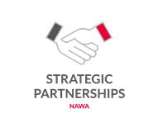 Agreement number: BPI/PST/2024/1/00034/U/00001

