“ALEKSANDËR MOISIU” UNIVERSITY DURRËS
FACULTY OF EDUCATION

in partnership with:

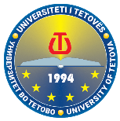
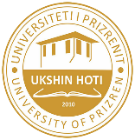
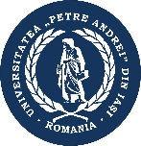

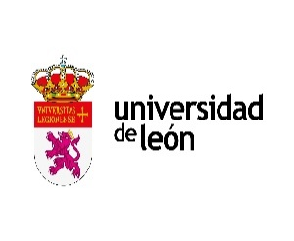
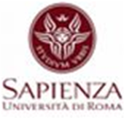

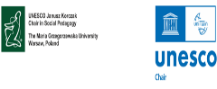
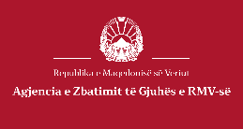
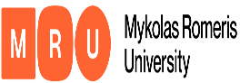

Organizes

The 8th International Conference

Shaping the Future:

Education & Innovation in a Digital Society

April 29th – 30th, 2026
Hybrid (on-site and online)
Faculty of Education is happy to invite to the following event:

8th INTERNATIONAL CONFERENCE

“SHAPING THE FUTURE: EDUCATION & INNOVATION IN A DIGITAL SOCIETY”

April 29th – 30th, 2026

Format: Hybrid (on-site and online)

The Faculty of Education of “Aleksandër Moisiu” University Durres, in cooperation with international partners: “Constantine - The Philosopher” University in Nitra, Slovakia; “La Sapienza- Universita Di Roma”, Italy; “Pegaso” Napoli University, Italy; University of León, Spain; “Petre Andrei” Din Iași University, Romania; "Dunarea de Jos" University of Galati, Romania; UNESCO Janusz Korczak Chair in Social Pedagogy, “Mari Grzegorzewska” University, Warsaw, Poland; Institute of Humanities-Faculty of Human and Social Studies, “Mykolas Romeris” University, Vilnius, Lithuania; Tetova University, North Macedonia; Agency for the Implementation of Language, North Macedonia; and “Ukshin Hoti” University Prizren, Kosova is going to organize the 8th International Conference “Shaping the Future: Education & Innovation in a Digital Society” to be held on April 29th – 30th, 2026, in Durrës and will follow a hybrid format (both onsite and online participation).
The conference aims to address and discuss the profound transformations that digitalization, new technologies, social changes and cultural developments are bringing to the field of education, humanities and social sciences, offering a different shape and perspective to the future generations.
The Faculty of Education invites scholars, researchers, field experts, policymakers, and postgraduate students, domestically and internationally, to submit their abstracts for the eighth international conference “Shaping the Future: Education & Innovation in a Digital Society”.
This interdisciplinary conference welcomes scientific contributions that offer theoretical reflections, empirical results, innovative practices, policy analyses, and perspectives on the future of education and society.

Conference Topics and Sub-Topics:

- Innovation & Technology in Education
• Innovation & Technology in Education
• Teacher Inclusion & Well-being
• Contemporary Research Methods in Education
Link to apply: https://forms.gle/UPG2rtF7kGfYXeuS6

- Mental Health, Youth and Social Well-Being
• Mental health and artificial intelligence in Generation Z.
• Parenting, identity and risky behaviours.
• Positive development of individuals with disabilities.
• Internet and emotional well-being, bullying, hate speech, human trafficking
Link to apply: https://forms.gle/eLgwdhdgEDVehEcq5

- Philosophy, Society and Digital Transformation
• Modern Philosophy and the Foundations of Change in Digital Society
• Digital Innovation and Social Transformation: Ethics, Institutions, and Society in Transition
• Migration, Family, and Education: New Social Realities in the Digital Age
• From Digital Chaos to Creative Order: Digital Citizenship and the Human Dimension of Education
Link to apply: https://forms.gle/tXwDh6G9TZ8pVNtc6

- Lifelong Learning & Social Sciences
• Lifelong Learning & Digital Competence
• Gerontology
• Early Childhood Education
Link to apply: https://forms.gle/B6PsE3j1RSJUGCSRA

- Albanian Language, Culture, and Globalisation
• Albanian language identity in the era of globalization
• Linguistic norms in the era of digital communication. Albanian language teaching challenges.
• Development of intercultural competence through the Albanian language
Link to apply: https://forms.gle/NtUpQhkJEukHNgys9

- Foreign Languages and AI
- Innovative approaches in foreign language teaching: Linguistics, literature and culture
- The integration of Artificial Intelligence in Second Language Acquisition
Link to apply: https://forms.gle/F42vvrUpAHj81uRf6

- Literature in the Digital Age
• Literature in the digital age: from printed text to interactive experience and new aesthetics of reading.
• Innovative pedagogy in teaching literature in the digital age.
• Literature as a bridge between classical humanism and contemporary digital ethics
Link to apply: https://forms.gle/EvwMeZPuB4Q4zA8r6

Conference official languages: English

Conference and publication fee
UAMD | Partner universities | Conference participants
Free | Free | 50 euro

Important Dates
- Abstract submission deadline: February 1, 2026
- Notification of acceptance: within 5 days of abstract submission
- The deadline for the submission of the conference paper: February 28, 2026
- Conference program: March 18, 2026
- Conference dates: April 29–30, 2026

Submission Guidelines
- Abstracts should be 150–250 words, clearly outlining the research purpose, methodology, results, recommendations and expected contribution (12 points, Times New Roman, Justified, Single-space). The abstract should not contain tables and graphics.
- Keywords: 3-6 words (12 points, Times New Roman, Italic)
- Papers may be presented in English.
- Eligibility: Only authors whose abstracts are accepted will be invited to submit and upload a full paper.
- Note: The guidelines for full paper formatting will be sent to you upon acceptance.

How to Submit Your Application
The conference is organized around multiple thematic topics and sub-topics. Each thematic topic has its own dedicated submission form.
- Choose a Theme: Review the list of conference themes and select the one that best fits your research.
- Follow the Link: Click on the submission link provided next to your chosen theme. This will take you to the Google Form for that specific topic.
- Submit Your Application: Complete the form with all required details, including your abstract and personal information.
Note: Only abstracts submitted through the correct theme link will be considered for review.

Contact: For questions regarding the conference and submissions please contact the following email address: conferencefe@uamd.edu.al

We welcome you to “Aleksandër Moisiu” University, Durrës, Albania
Conference Organizing Committee

