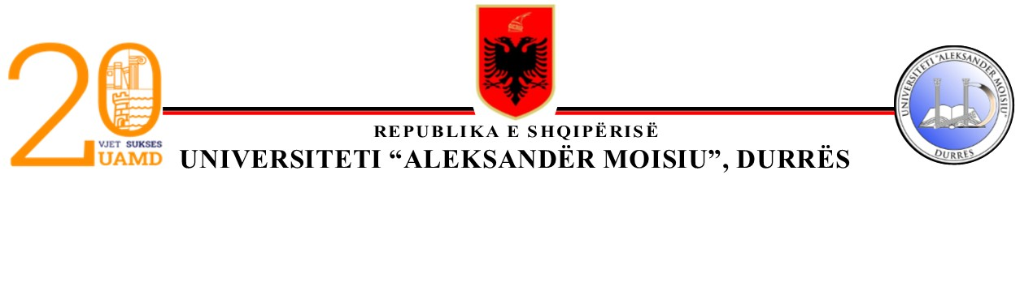

ADMINISTRATORI

Nr.________Prot. Durrës, më ___.___.2025
SERVICE CONTRACT
Financed by Commission financing decision n° [insert number(s) of the Commission financed from the Italian -Albanian Debt for development Swap Agreement – IADSA II
MAIN CONDITIONS
University Aleksandër Moisiu, Durrës
St “Taulantia”
Durres, Albania

(‘the contracting authority’),
of the one part,
of the one part, and
and
Contractor name represented for the purposes of signing this contract by the authorised representative indicated in the respective field under “SIGNATURES” below,
on the other part,
HAVE AGREED as follows:
1. Subject matter
The title of this contract is: “Clean up day in Durrës selected site”
The terms and conditions applying to this contract are laid down hereafter and in the special and general conditions and their annexes. They shall be deemed to form and be read and construed as an integral part of this contract in the order described in the special conditions.
2. Contract value
The maximum amount covering all purchases under this contract is euro, 3,500 (three thousand five hundred).
3. Entry into force and duration
This contract enters into force on the date on which the last party signs it.
4. Bank account
Payments shall be made in accordance with the special conditions into the following bank account:
Name of bank: [insert bank name]
Exact denomination of account holder: [full name of account holder]
Bank account number: [insert bank account number].

Signatures

For the contractor |  | For the contracting authority

